Laughton All Saints’ C of E Primary School

RELATIONSHIPS AND SEX EDUCATION (RSE) POLICY

2023-2024

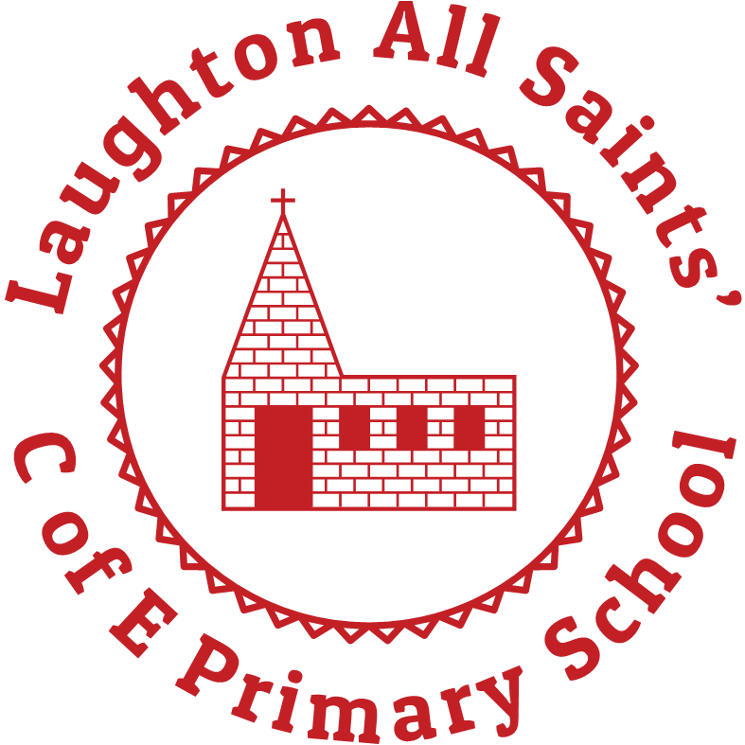

Accepted by staff: January 2023

Accepted by Governing Body: February 2023

Date of Review: February 2024

**RELATIONSHIPS AND SEX EDUCATION (RSE) POLICY**

Introduction

Relationship and Sex Education (RSE) is part of a planned programme of Personal, Social and Health Education in our school. The values which underpin the whole of this work are based on the pupils at Laughton All Saints’ knowing how to be healthy, safe and live their lives in a positive way. The building blocks and characteristics of positive relationships including family, friendships and relationships with other children and adults are introduced from FS2 and built on progressively throughout the curriculum. The teaching is balanced with factual information which gives the pupils an opportunity to discuss issues in a safe and supportive environment, which is honest and open. There is recognition that within the school there are a variety of different values which arise from different religions and cultures, special educational needs, social circumstances and upbringing.

Statement of Intent

RSE aims to help pupils to develop caring and positive relationships in which the right of others are acknowledged and respected.

We teach children about;

• the physical development of their bodies as they grow into adults;

• the importance of family life;

• the diversity of families;

• the acquisition of skills necessary to cope with relationships and related situations;

• respect for the views of other people.

Teaching and learning

We teach RSE in the context of the school’s aims and values to meet the appropriate physical and emotional maturity of the children.

We use the programme ‘Jigsaw’ in school, which covers all areas of PSHE for the primary phase including statutory

Relationships and Health Education. The table below gives the learning theme of each of the six Puzzles (units) and these are taught across the school; the learning deepens and broadens every year.

|  |  |  |
| --- | --- | --- |
| Term | Puzzle (Unit) | Content |
| Autumn 1: | Being Me in My World | Includes understanding my own identity and how I fit well in the class, school and global community.  Jigsaw Charter established. |
| Autumn 2: | Celebrating Difference | Includes anti-bullying (cyber and homophobic bullying included) and understanding |
| Spring 1: | Dreams and Goals | Includes goal-setting, aspirations, who do I want to become and what would I like to do for work and to contribute to society |
| Spring 2: | Healthy Me | Includes drugs and alcohol education, self-esteem and confidence as well as healthy lifestyle choices, sleep, nutrition, rest and exercise |
| Summer 1: | Relationships | Includes understanding friendship, family and other relationships, conflict resolution and communication skills, bereavement and loss |
| Summer 2: | Changing Me | Includes Relationships and Sex Education in the context of coping positively with change |

It is recognised that some staff may find it uncomfortable and may lack confidence in teaching these objectives. If this is the case, every effort will be made to provide support either through the use of resource materials, additional training or in classroom support.

We teach RSE through our personal, social and health education (PSHE) curriculum where children learn about sex and relationships and where appropriate through other subject areas (for example, science and PE) e.g. in science we teach about the parts of the body and how these work.

At times it is recognised there may be a need to work in single gender groups where some issues may be discussed more openly. Teachers do their best to answer all questions with sensitivity and care. The issue of sexual orientation is one which may feature in discussions about sexuality. If this does arise, teachers will need to give objective information and allow balanced discussion.

A wide variety of teaching strategies are employed, including group work, discussion, appropriate videos and role play. The use of a wide variety of learning opportunities is seen as a key to the success of this programme, as is the differentiation of materials used.

We consult with and send out information to promote parental engagement in the RSE programme. This engagement explains what RSE is and how it is taught and to invite parents to see the materials the school uses in its teaching.

All resources used are chosen with the developmental needs of pupils in mind and are evaluated on the grounds of the suitability for particular groups.

Impact

Teachers annotate planning and make alterations to reflect the learning taking place. The RSE programme is evaluated as a result of feedback from pupils and staff involved in the teaching. Changes and developments are made in light of this feedback in order to keep up to date and respond to the changing needs of the

pupils.

The role of parents

The school is well aware that the primary role in children’s RSE education lies with parents and carers. We wish to build a positive and supporting relationship with the parents and carers of children at our school through mutual understanding, trust and cooperation. In promoting this objective we:

• inform parents and carers about the school’s RSE policy and practice;

• answer any questions that parents may have about the RSE of their child;

• take seriously any issue that parents raise with teachers or governors about this policy or the arrangements for RSE in the school.

The role of other members of the community

We encourage other valued members of the community to work with us to provide advice and support to the children with regard to health education. In particular, members of the Local Health Authority and other health professionals, who give us valuable support with our relationship education programme.

Confidentiality

Teachers conduct relationship education lessons in a sensitive manner and in confidence. However, if a child makes a disclosure to being involved, or likely to be involved in sexual activity, then the teacher will take the matter seriously and deal with it as a matter of child protection. Teachers will respond in a similar way if a child indicates that they may have been a victim of abuse. In these circumstances the teacher will follow the school’s safeguarding procedures.

The right to withdraw

Parents have the right to withdraw their child from all or part of the RSE programme that we teach in our school. If a parent wishes their child to be withdrawn from RSE lessons, they should discuss this with the Headteacher and make it clear which aspects of the programme they do not wish their child to participate in. The school will, before any request is granted, provide the benefits of receiving this important education and the detrimental effects the withdrawal may have on a child. Should the parent still wish to withdraw their child then the school is to document this to ensure a record is kept. The school always complies with the wishes of the parents in this regard.