

Laughton All Saints’
Church of England Primary School

Wrap Around Care Booklet
2025 / 2026


Welcome to our Wrap Around Care services, designed to support families with flexible, safe, and nurturing childcare before and after school hours.

Head teacher: Mrs J Armitage

High Street, Laughton-en-le-Morthen,
Sheffield, S25 1YF
Telephone: 01909 550531
Email: office@las.dsat.education
Website: https://www.laughtonallsaints.org

At Laughton All Saints’, we understand the needs of working parents and are proud to deliver our own Wraparound Care Package, tailored to the requirements of our school community.
Our Wraparound Care is provided on our school site and all clubs are ran by experienced and established school staff members. This means they know your children incredibly well, as they work in school full time, and adapt activities to suit your child’s interests and needs.
Our various offerings start at 07.45 and finish at 17:45 and is open to all children from Nursery through to Year 6.

🥞 Breakfast Club
Time: 07:45 – 08:40
Daily Charge: £3.50
Staff Members:
- Miss Phillips
- Mrs Newman
Food Options Include:
- Toast
- Pancakes
- Crumpets
- Cereal
Drinks Available:
- Orange Juice
- Apple Juice
- Milk
Breakfast Club provides a calm and friendly start to the day, with a variety of healthy breakfast choices and engaging activities to ease children into their school routine.

🌈 After School Club
Time: 15:25 – 17:45
Daily Charge: £8.50
Staff Members:
- Mrs Newman
- Mrs Peacock
- Miss Phillips
🕒 1-Hour Activity Sessions
Time: 15:30 – 16:30
Charge: Included in full session or available separately for £3.50
Children booked onto the 1-hour session will engage in set activities:
🎨 Monday: Arts and Crafts
🧱 Tuesday: Lego
👨‍🍳 Wednesday: Tasty Creations Club
🎵 Thursday: Music Club
🎮 Friday: Games Club
These are structured activity sessions (not free-flow like our main after school club), so children will participate in the day's set activity.
Drinks and a Biscuit will be provided. Please note: no meal is served during the 1-hour session.
🍽️ Full Session Details
Meals are served between 16:30 – 17:00. Children booked onto the full After School Club will:
- Enjoy a nutritious meal, snacks, and drinks (As per our 3-weekly menu)
- Have freedom to choose from a range of activities led by our After School Club staff
- Spend time outside on the playground (weather permitting)
- Join in with set activities if they wish
Our After School Club offers a safe and stimulating environment for children to relax, play, and learn after the school day ends.

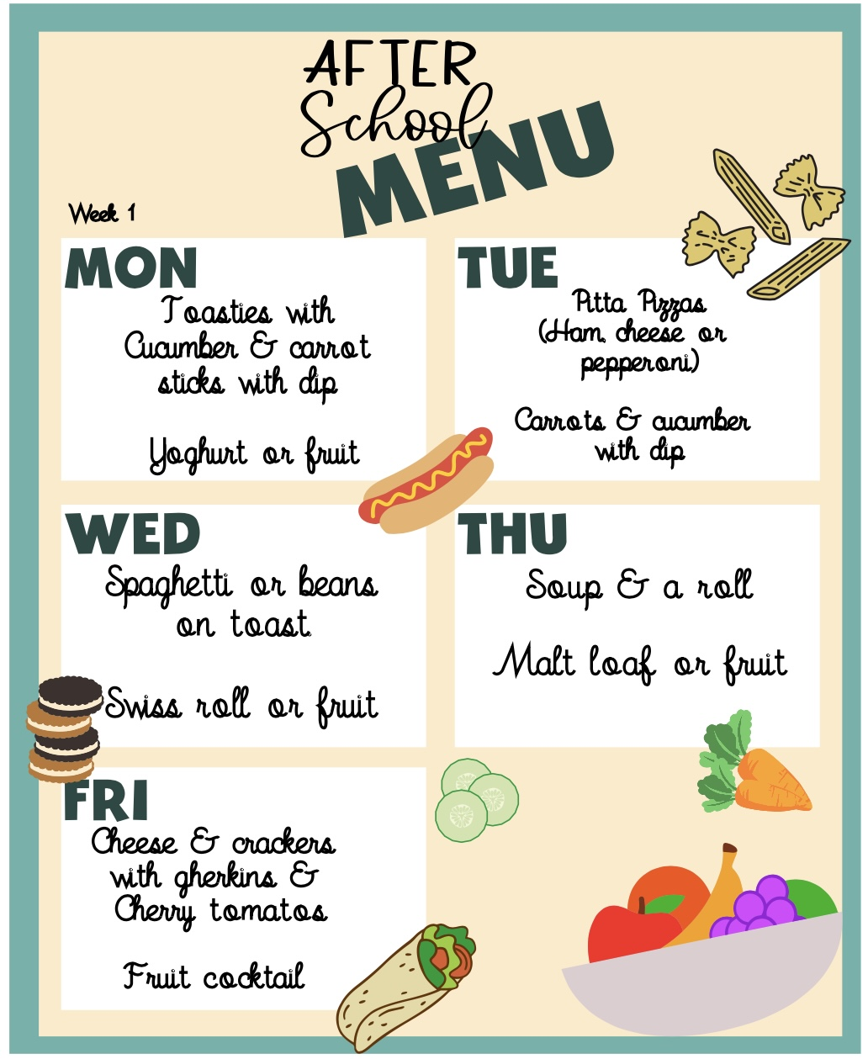

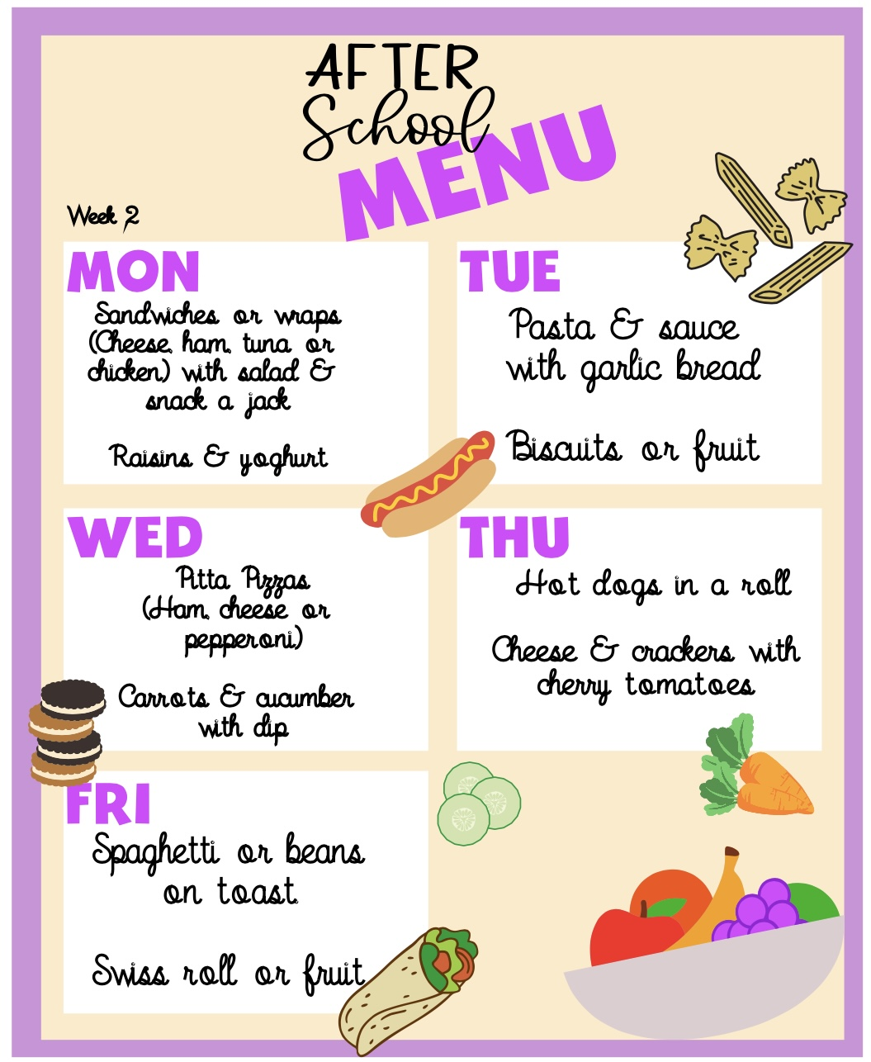

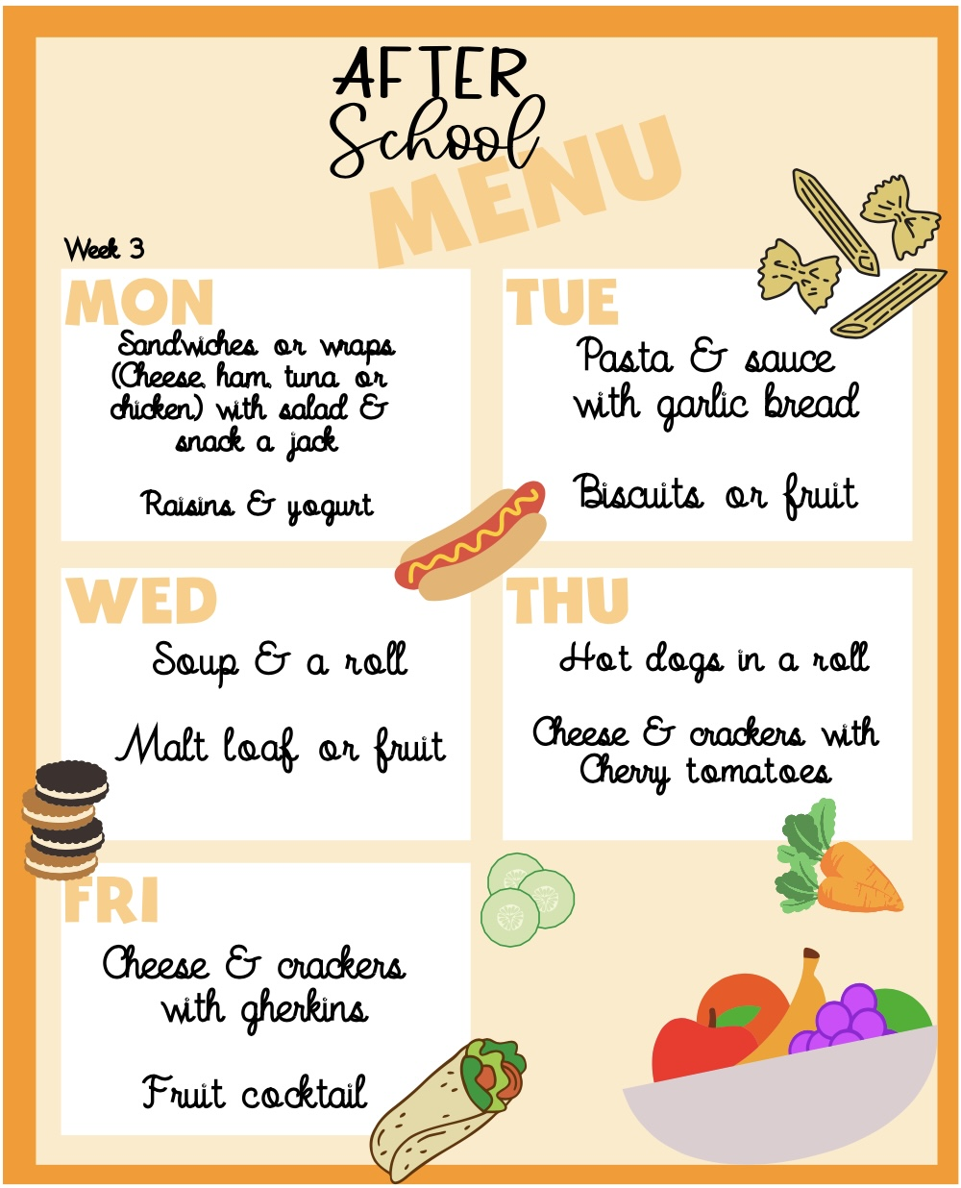

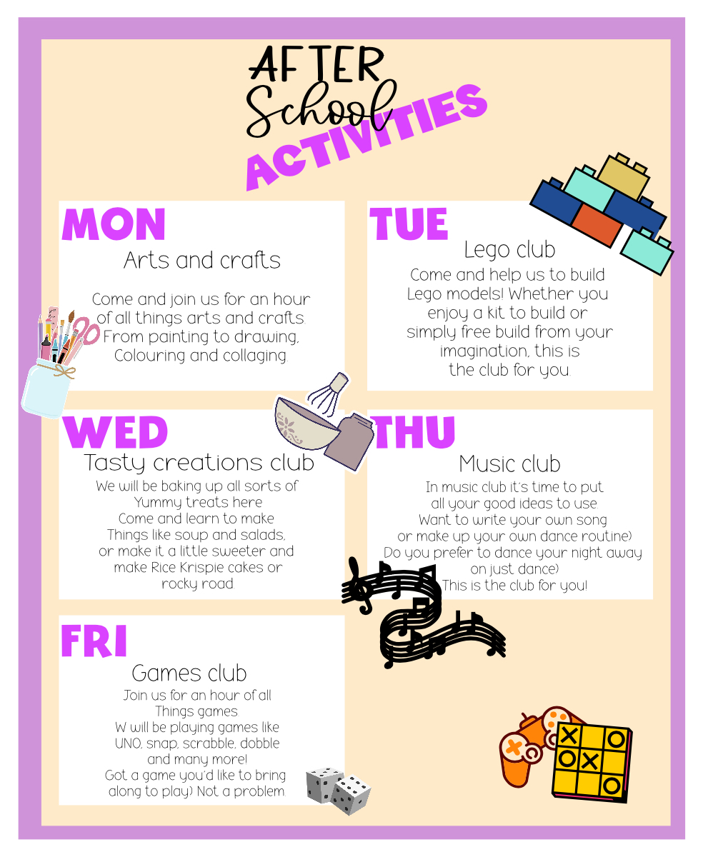

How to book?
Sessions are bookable via Arbor - Funds are required to be available on your account to enable the booking to be processed.
For Tax free childcare payments, please contact the school office to indicate which sessions you require for each month and an invoice will be generated for you, all invoices must be cleared by 28th of each month, failure to do so may result in the forfeit of all further sessions until balance is cleared. Further information about Tax Free Childcare / Childcare voucher payment options can be discussed with the school office.

Late Collections
In the event that your child has not been collected after the end time from Extended After School Club (17:45), a late collection charge will be issued to cover the additional staffing and on-costs associated with this.
If you are late picking up after 17:50, you will incur a £5:00 charge for each 15mins you are overdue.

