Painting Progression

Light and dark
Stage One
Show examples of tone (light and dark) in artwork.
- Where has the artist used light and dark?
- Why has the artist used light and dark (so things look far away, closer, to show the shape of an object- form)

Stage Two (when drawing)
- Look at objects under lighting conditions (we have lamps in the art room) and identify areas of light and dark on an object. How could you show light and dark in your art work?

Stage Three (drawing)
- Look at the range of tones from light to dark. We can create tone using line (lines close together and far apart). We can create tone by changing the pencil pressure.

Stage Four
- Understand tonal contrast, how has the artist used contrast in this picture? Why has the artist used different tones? What mood is the artist trying to create.
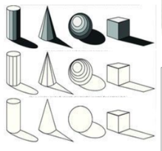
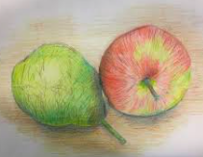
Colour Theory

Colours come in all sorts of different shades

Mix colours together to create different shades

For example;
Green= blue and yellow
To make a different shade of green mix:
Dark green= add more blue than yellow (you can add black)
Light green= add more yellow than blue (you can add white)

Colour names progression (label on a colour wheel in sketchbooks)

Stage 1
- Red, blue, yellow (primary colours)

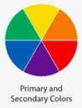

Stage 2
Orange, green purple (secondary colours)

Stage 3
- Light blue, dark blue, pale blue (basic shades)

Stage 4
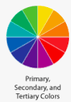
- Tertiary Colours (mix secondary colours together)

Stage 5
- Red, orange, yellow, gold, maroon, terracotta, coral, peach, rust, burgundy, mauve (warm colours)
- Aqua, teal, turquoise, cyan, indigo, lavender, mint (cool colours)

Stage 6
- Colour schemes- pastels, earth tones, neon-style and mood board, purpose.

Stage 7
- Cultural associations. In Islam, green is believed to bring blessings, blue protects, white symbolises purity, gold symbolises wealth and prosperity, black is associated with mourning,

How to use a colour wheel- colour schemes
Complementary colours, complement each other - opposites attract.
(blue skies complement orange sunsets)

Adjacent colours sit next to each other on the colour wheel.

Adjacent colours are similar and create harmony. (warm and cool colours)

Colour Mixing Progression

Stage 1
- Mixing primary colours – correct yoghurt consistency.

Stage 2
- Mixing secondary colours (mix two primary colours to make secondary colour) – yellow and red make orange.
- Mixing two colours together and experimenting. Give the children blue and white, or blue and red- what happens.

Stage 3
- Challenge the children to mix a specific shade (Reception, year 1 and 2)

Stage 4
- Teach cool and warm colours- adjacent colours on the wheel. (year 1 and 2)
- Teach complementary colours- opposite on the wheel. (year 3 and 4)

Stage 5
- Explore how colour is used to convey mood and cultural associations. (year 6 and 5)

Painting skill progression (always revisit brush care and paint consistency)

Stage 1
- Hold a brush correctly (Bob the brush)
- Make the correct paint consistency (creamy yogurt)
- Paint freely

Stage 2
- Paint with big brushes; lines, straight, squiggles, zig zags.

Stage 3
- Paint shapes
- Paint shapes and colour in with paint

Stage 4
- Stippling with big brushes (KS1)

Stage 5
- Paint lines and shapes with a thin brush and with accuracy (KS1, LKS2)

Stage 6
- Create different textures using powder paint (UKS2).

Stage 7
- Paint repeated patterns with accuracy (UKS2)

EYFS (Cycle A) Painting
Artist and Painting
Wassily Kandinsky:  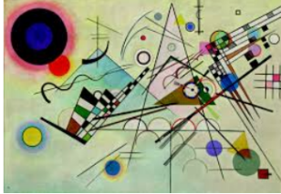 | Pay Attention to Kandinsky’s art
Line: Circles, straight line, wavy line, zig-zag line, triangle, circle.
Colours: Teach: Red, Blue, Yellow, Orange, Green, Purple (Stage 1 and 2)

Deliberate painting practice (skills and habits) | Independent Practice (Final artwork)
Painting habits- including Bob the Brush care.  Mixing yoghurt consistency.  Lesson 1- paint different lines with a thick and thin brush: Straight, squiggles, wavy, zig zag  Lesson 2- paint circles  Lesson 3- paint triangles | A LARGE painting with lines, circles and triangles. ‘like Kandinsky’.
What will leaders check
Line: Children can recognise on flashcards: wavy line, zigzag line, straight line, triangle and circle.
Colour: Children recognise primary and secondary colours on flashcards.
Form: The children can draw circles and different types of lines- this will be evident in a large final independent piece of art work.
Texture: The paint is mixed to creamy yoghurt consistency.

EYFS (Cycle B) Painting
Artist and Painting
Piet Mondrian, Netherlands, Abstract Art: Shapes and Colours.  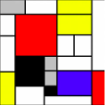 | Pay Attention
Explain that Mondrian used to paint streets from a bird’s eye view. The black lines are the streets and the blocks are ‘street blocks’ in America.

Line: How many oblongs can you see? How many white squares? Red squares?

Colour: yellow, red, black and grey.
Deliberate painting practice (skills and habits) | Independent Practice Final artwork
Painting habits- including Bob the Brush care.  Mixing yoghurt consistency.  Lesson 1- paint different lines with a thick and thin brush. Can you cross the lines to make squares and oblongs?  Lesson 2- Children to create own art work by drawing long lines horizontally and vertically to create oblongs.  Lesson 3- Children to paint blocks of colours.  Lesson 4: Children to paint black outlines around blocks. | A large painting with different shaped oblongs with black outlines.  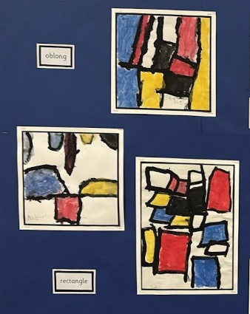
What will leaders check
Line: Children will draw horizontal and vertical straight lines using a thick and or thin brush.
Colour: Children recognise primary and secondary colours on flashcards.
Form: Children will paint blocks of colour in the lines.
Texture: The paint is mixed to creamy yoghurt consistency.

KS1 (Cycle A) Painting
Artist and Painting | Pay Attention
Claude Monet,  French Painter  Impressionism (create a feeling).  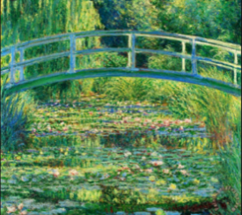 | Where is the painting dark? Where is the painting light? Why has the artist used light and dark (to show shadow, make things far away, to show 3D form).  Revisit primary and secondary colours- which primary colours has the artist used? Secondary? How do we make secondary colours?  Colour theory: Stage 3 - Mixing dark and light shades of green. Add more yellow (light shade) add more blue (dark shade)
Deliberate painting practice (skills and habits) | Independent Practice Final artwork
- Teach painting habits including brush care.  - Sketchbook: Use a colour wheel to make green. Make different shades of green using, white, yellow and blue. Can the children make a specific shade of green in their sketchbook.  - Sketchbook: How to paint using stippling (without damaging Bob the brush). Paint with cool colours from the colour wheel. | Large creation of Monet’s art. Children to map out the picture using pencils.  Children to paint different shades of green.  Children to use big and small brushes to create a Monet picture.  Children to use the stippling technique.
What will leaders check
Evaluation:
My painting has light and dark parts.
I have mixed different shades of green.
I have mixed different shades of blue.
My paint is creamy yoghurt.

KS1 (Cycle B) Painting
Artist and Painting | Pay attention
Henri Rousseau, French Painter, Impressionism (create a feeling).  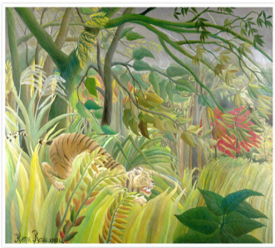 | Where is the painting dark? Where is the painting light? Why has the artist used light and dark? (to show shadow, make things far away, to show 3D form).  Revisit primary and secondary colours - which primary colours has the artist used? Secondary? How do we make secondary colours?  Colour theory: Stage 3 - Mixing dark and light shades of green. Add more yellow (light shade) add more blue (dark shade)
Deliberate painting practice (skills and habits) | Independent Practice (Final artwork)
- Teach painting habits including brush care.  - Use a colour wheel to make green. Make different shades of green using, white, yellow and blue. Can the children make a specific shade of green in their sketchbook.  - Show children how to gradually make the green darker.  - Teach the children how to draw different leaf forms like Henri Rousseau.  - Model painting techniques by filling in the shapes with different patterns. See PowerPoint. | Create a Henri Rousseau style painting. Children to copy Henri’s leaf shapes and paint them in different shades of green. Different paint techniques: Gradually painting a lighter line, blocks of colour, dots of colour.  Children to only use blue, yellow and white paint.  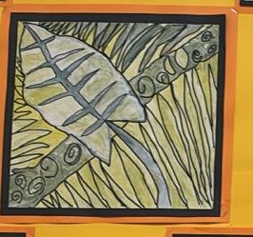
What will leaders check
Evaluation:
My painting has different leaf shapes
I have mixed different shades of green
I have created different paint patterns
My paint is like creamy yoghurt

LKS2 (Cycle A) Painting
Artist and Painting | Pay attention
Georgia O’Keeffe, American Painter, Modernism- innovation and experimentation  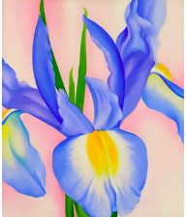  Lavender Iris | Georgia has painted a section of the flower- not the whole flower.  She has used commentary colours- show on colour wheel.  Where has Georgia used light and dark? Why are some parts of the petals darker, lighter? How does Georgia make the paint lighter or darker? The paint colour? Link to how tone creates form (3D).
Deliberate painting practice (skills and habits) | Independent Practice (Final artwork)
- Teach painting habits, including brush care.  - Using a thin brush, children paint a section of Georgia’s painting (see PowerPoints) model how to make the colour gradually get darker by painting thin lines next to each other. Can you make 10 shades of lavender?  - Children to practice sketching out Georgia’s art work. They can do the same picture, or enlarge a section.  - Teach the colour lavender, peach, rust, | Create a large version of Georgia O’Keeffe’s painting Lavender Iris.  Children must demonstrate their colour mixing skills. Children decide on a colour scheme - warm colours, cool colours or complementary colours. They must explain their decisions.
What will leaders check
Evaluation:
I have mapped out my work.
I have mixed different shades of colour.
I have created different paint patterns.
My paint is creamy yoghurt.
Explain how you used the colour wheel.

LKS2 (Cycle B) Painting
Artist and Painting | Pay attention
Vincent Van Gogh, the Netherlands, Impressionists, create a feeling.  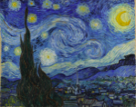  The Starry Night | Children to identify how the artist has created light and dark in the painting.  Texture is created by using lots of different shades of the same colour. The artist changes the direction of the brush to create movement in the picture (texture).  The artist has used complementary colours.  What mood is Vincent trying to create? Play the music Starry, Starry Night.
Deliberate painting practice (skills and habits) | Independent Practice (Final artwork)
- Teach painting habits and brush care.  - Mixing different shades of blue. Try to make the same labelled shade in sketchbooks.  - Aqua, teal, turquoise, cyan, indigo,  - Practice painting swirls close together with different sized brushes in sketchbooks - how do you create movement? When layering, paint light to dark and then dark to light, which do you prefer? | Draw own version of Starry Night and paint using powder paint.  Map out the key points- horizon, trees, swirls.  Children paint Starry Night- discuss how to keep yellows ‘bright’.  Children can use any complementary colours. Red and green, blue and yellow, orange and purple.
What will leaders check
Evaluation:
I have mapped out my work.
I have mixed different shades of colours.
I have created movement in my painting.
My paint is creamy yoghurt.
Explain how you used the colour wheel.

UKS2 (Cycle A) Painting
Artist and Painting | Pay attention
Wassily Kandinksy  Russian Painter  Abstract art - not an accurate picture. Uses shapes, colours, forms and marks to achieve an effect.  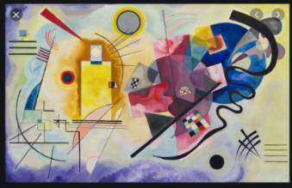 | The use of colour- synesthesia. What is Kandinsky trying to show in this painting? What do the black lines represent? How do the shapes make you feel?  How is the artist showing depth and texture?
Deliberate painting practice (skills and habits) | Independent Practice (Final artwork)
Revisit painting habits and brush care.  Teach children the concept of abstract- they will create a definition using a definition sorting activity.  Teach how to add texture to paintings – Using masking tape to create a straight line, wet-on-wet sponge technique, splatter technique, adding PVA for texture, | Children to listen to music and create a painting that represents the music. Children to draw shapes, and paint using powder paints, create texture using taught techniques. Use Kandinsky’s colour theory. During the evaluation, children to explain their artistic decisions.
What will leaders check
Evaluation:
I have mapped out my Kandinsky painting.
I have used three different paint techniques.
I will mix different shades of a colour.
The colours and shapes in my painting will tell a story.

UKS2 (Cycle B) Painting
Artist and Painting | Pay attention
Islamic Art  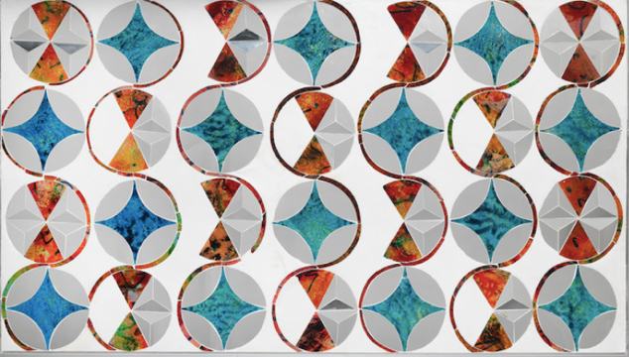  Traditional Islamic Art  Stars by Monir Farmanfarmaian (Iran, 1924-2019)  Contemporary Islamic Art | Introduce the artist Monir Farmanfarmaian. This video is great for the history of Islamic art but how it is designed too. https://www.youtube.com/watch?v=pg1NpMmPv48  How has the artist used light and dark? Using cultural associations sheet - why do you think the artist has used these colours?  Monir’s art starts with a circle - what do you notice about her designs? How has she used pattern? Texture?  Most Islamic art is mainly patterning and avoids drawing people as this could be seen as idolatry. Instead you see geometric, abstract shapes and representations of nature.  Potent symbols in Islamic art are flowers, water, symbols of life, survival and paradise- see PowerPoints.
Deliberate painting practice (skills and habits) | Independent Practice (Final artwork)
- Revisit painting habits and brush care.  - Children to imagine that their art work will be displayed in the Town Hall- what would you like your painting to represent? What colours, shapes, pattern symbols will you use?  - Practice drawing and painting different nature symbols, cypress, branches, open rose, dropping tulip.  - From the knowledge of colour, children chose a colour scheme and explain their choices in their sketchbook.  - https://www.youtube.com/watch?v=27iVbB656a0 draw an Islamic style pattern is a good one for drawing a simple design. Investigate online, choose and copy the whole or parts of designs you like best, colours and shapes you like. Keep them simple. | Draw their own geometric pattern. Use an Islamic symbol and incorporate within the geometric pattern.  Decide on a colour scheme- warm/cool colours with dark tone running through the art work.  Paint with accuracy. Show in their painting the following techniques.  Thin strokes- gradually getting darker/ lighter.
What will leaders check
I have created an Islamic geometric shape.
I have mixed different shades of colour.
I have added paint layers.
My paint is creamy yoghurt.
Explain why you have used certain colours and symbols.

