

**LAUGHTON ALL SAINTS’ C OF E PRIMARY SCHOOL**

Spring Term 1 2024 Newsletter



It has been great to see everyone back in school again and to catch up with what your children have been doing during the Christmas break. We hope you all had the opportunity of making some lovely memories during this festive period.

In this term's newsletter, you will find information about forthcoming events and plans for our classes and the school, as well as an overview of last term's activity. If there is anything you would like further clarity about, please do get in touch.

**Curriculum Updates:**



SInce the beginning of the year, we have made several changes to the content of our curriculum and the way we plan and deliver some of our subjects. This doesn't always mean that what has gone before hasn't been suitable. We sometimes just need to move with recent developments and to ensure our pupils are receiving the best possible teaching and provision. Here are some of the adjustments we have made.

Maths: Our school uses the White Rose Scheme from the Foundation Stage to Year 6. This year, we have invested in the scheme, class work books for consistency and to ensure pupils have more relevant and timely practice of skills. This is working very well and pupils report that they like the new resources.

We have invested in the Reflex Maths online tool to allow our pupils greater opportunities to learn key facts - number bonds in KS1 and Multiplication facts at KS2 – and develop fluency of recall. Reflex provides fun activities for pupils on an online platform and also enables teachers and leaders to analyse progress and direct their teaching to bridge gaps in learning. All pupils have been issued with login details so they can also learn at home. Please encourage your child to use Reflex regularly. If your child does not have access to a suitable device, please let us know. We may be able to provide support.

Computing: We are delighted to share that we have recently made a considerable investment into computing hardware. All pupils have access to newly purchased devices and have their own google accounts. These facilities are already making a difference to the quality of learning experiences. This is the first stage of our plans to upgrade the technology in school.

Art: This term, we have begun to use a new Art scheme. The scheme breaks down teaching into much smaller steps and enables pupils to explore a range of artistic styles and techniques used by key artists. At the end of the year, it is our intention to hold an art exhibition to share our journey and celebrate processes and outcomes. Watch this space!

Reading: Read, Write Inc. continues to be the back-bone of Early Reading in our school. From the beginning of the year, pupils in the Foundation Stage and Key Stage 1 have been working in small groups to secure and build on their phonic knowledge, to become fluent readers. Staff training is an integral part of our phonic programme and takes place regularly. Our staff have access to a wealth of resources and have most recently been praised by our RWInc trainer for their hard work and fidelity to the programme.

If your child is no longer on the RWInc programme, they will be learning more in-depth comprehension skills and reading book-banded books. Whichever level your child is working within, it is important that they have regular opportunities beyond school, to practise and develop a love for reading. If you would like further information about how to support your child with phonics or later reading at home, please get in touch.

We are still on the look-out for MYSTERY READERS! Thank you to all who attended school last term to surprise our pupils. You were great!

Writing: We have recently introduced a handwriting policy and procedures to raise standards in the subject. Teaching follows the Read, Write Inc letter formation guidance and introduces the use of special lines and the range of joins as the programme progresses. Pupils practice daily in the Early Years and KS1 and at least 3 times per week in KS2.

# **School Lunches**



In the last 2 weeks before the Christmas break, in response to pupil voice, we changed our lunch sittings so that pupils in each key stage can spend their lunch-times together - regardless of whether they have school lunches or packed-lunches from school. This has worked well so far and pupils report that they always have someone to play/spend time with from their own social circles.

Since the start of the year, we have been in an unfortunate position of having temporary, agency staff in our kitchen, rather than a permanent school cook and assistant. Prior to Christmas, I requested visits from key staff at Taylor Shaw to quality-assure the service in school. Since the start of the new year, there has been a change of staffing (now Taylor Shaw trained staff) and an increased oversight by our TS supervisor to monitor school meal provision. The quality of the meals provided is hugely important to us and we will continue to monitor this going forward.

It is important to us to have feed-back about the services we provide to know whether they are of the expected quality. Most recently, we have noticed that the uptake for school lunches is not as strong as it previously was. This, I appreciate, may be for a number of reasons. We will shortly be sending a short questionnaire to parents, to gather feedback about school lunches.

# **Attendance**

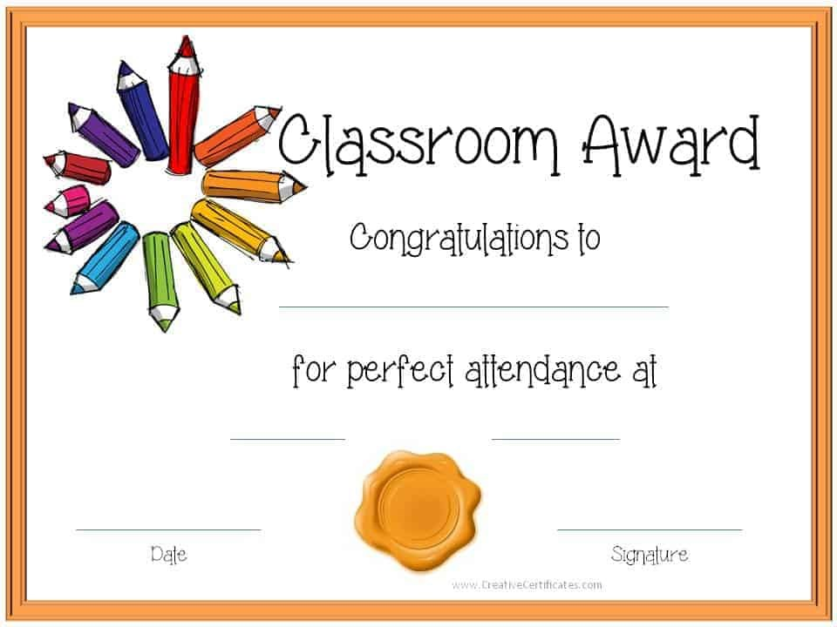

SECOND HALF TERM - October 31st - December 22nd.

Whole School Attendance - 95.21%

Class 1 - FS1 - 94% FS2 92.13%

Class 2- 96.75%

Class 3 - 96.44%

Class 4 - 94.49%

**********************************************************************************

We have recently introduced 'post-cards home' for pupils with 100% attendance during each term and will continue to use our weekly draw in the Celebration Collective Worship, to acknowledge excellent attendance. Seventeen children achieved 100% between September and December 2023.

We have updated our school attendance policy to reflect the policy recently introduced by our academy trust. The policy outlines the expectations of all stakeholders in ensuring that pupils regularly attend school and are punctual in doing so. To be transparent in our practices, we have included the standard letters issued to parents in instances where attendance falls below expectations. Details of specific school timings and what constitutes lateness/unauthorised absence are included. All families will be given a hard copy of the policy. The policy can also be found on our school website.

If you have any questions about your child's attendance or the policy, or if you would like further advice and support to ensure your child attends school, please get in touch. We have a very supportive Education Welfare Officer, who would be more than happy to make an appointment with parents who may need additional support.

# **Extra-curricular Clubs**

RUCT:

For the remainder of the school year, we are partnered with Rotherham United Community Trust. I have worked with the club previously and cannot praise their support, provision and professionalism enough.

Every week, on Mondays and Thursdays, RUCT staff will support the provision of P.E for all pupils, including the Foundation Stage. At lunchtime, staff will be on the playground providing and supervising physical activity. After school, club staff will lead invasion/football sessions for pupils in year groups 1 - 6. The partnership also allows us access to other activities and resources, including - free match-day tickets, tournaments an end of term inflatable session and joy of moving festival.

We are hoping to secure further clubs in the next couple of weeks.

# **Church and Community**



It has been a real pleasure and privilege to have spent many of our school events in All Saints Church, so far. Thank you so much for supporting these.

As you will be aware, the Church now has a Vicar in residence - The Reverend Beth Langner.

Rev. Beth has already visited our school and met with both children and staff and will be meeting with our Spiritual Council this month to discuss how we can forge even greater links with the Church and jointly support community projects.

CHURCH EVENTS:

<https://allsaintschurchlaughton.co.uk/>

# **Spring Term - Class Overviews**



There are some exciting projects planned this term and children have already begun their learning journeys in the range of curriculum subjects. Each of our subjects is taught discretely so that children learn how to become e.g. ‘historians’ and ‘artists’.

To find out more detail about the learning for this half term, please visit our website class pages and click the Spring Term 1 tab.

<https://www.laughtonallsaints.org/>

# **DIARY DATES for the coming term**



SPRING TERM 1

15th January Y5/6 Bike-ability sessions begin/RUCT extra-curricular clubs begin - Mondays and Thursdays

17th January Musical recital - whole school assembly

18th January                              Eucharist Service in Church – families welcome

24th January                              ‘Community Café’ 2:45 p.m.

w/c 29th January                      Storytelling Week

w/c 5th February                      Place to Be’s Children’s Mental Health Week

9th February                             Last day of term – school finishes at the usual times

SPRING TERM 2

19th February                            Children return to school

                                                     Young Voices – for Y3 to Y6@ Utilita Arena Sheffield (evening)

21st February                           ‘Community Café’ 2:30pm – all welcome

23rd February                            Family social event - TBC

23rd February                            Parents' Newsletter issued

29th February                            Book fair arrives in school – until 6th March

1st March                                   World Book Day – activities TBC

7th March                                 Open Morning for Parents 9 – 9:45a.m – time with your child in class

10th March                                 Mothers’ Day Service – All Saints Church 9.00 a.m. – all welcome

11th March                               Mothers’ Day Breakfast (Mums and children welcome)

W/C 11th March                         British Science Week ‘Time’

15th March                                Red Nose Day – dress in something funny!

w/c 18th March                         Easter Activity Week (inc. KS1 Easter Bonnet Competition and KS2 Egg Decorating and Egg Rolling Competitions

20th March                                ‘Community Café’ 2:30p.m – families welcome

20th March Parent meetings - 3.30 - 6.30p.m

21st March Parent meetings - 3.30 - 6.30p.m

26th March                                   Easter Service at 9:15a.m – families welcome

27th March                   Last day of term – school finishes at 2.30p.m

28th March                                    INSET DAY 5 – School closed to pupils